What You Can Try if no Red/White Oak or Sugar maple seeds are falling…

Some tree species like Red or White oak and Sugar maple do not produce seeds every year (which can be a natural result of environmental conditions or a strategy to manage predation).

If you are in the middle of a “non-mast year” when seeds from the above species are not plentiful (like Fall 2022), this is a great opportunity to try your hand at growing some other native Ontario trees that drop their seeds in the Fall. See the table below for a few possible alternatives. Go on and give it a try! Some links to YouTube resources have been provided to assist you.

Type of Tree (with scientific name and accompanying image) | Image of leaves and seed produced | Some interesting facts about the tree | Links to other helpful resources to assist with seed collection and growing
Shagbark Hickory (Carya ovata)  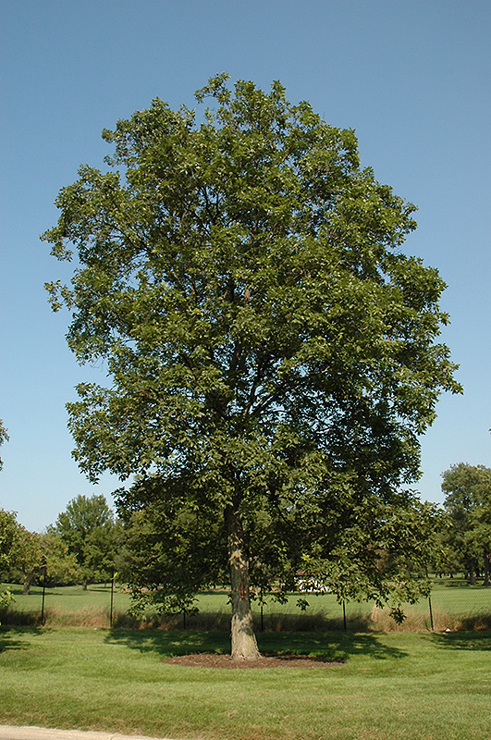  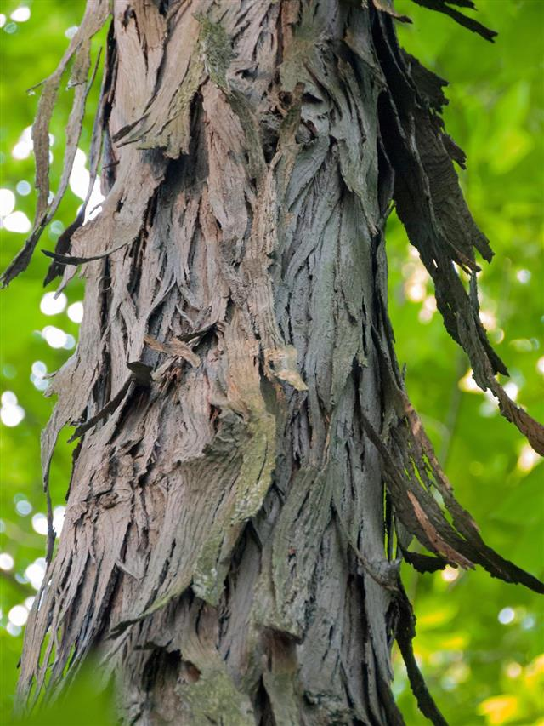 | 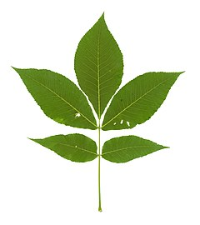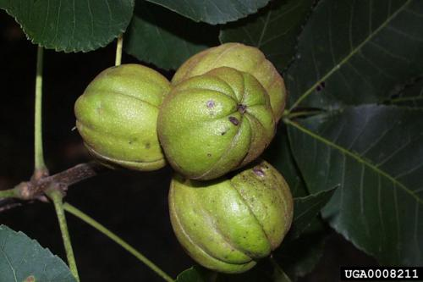 | This tree is readily identified by its unique “shaggy” bark that peels off in large strips.  Indigenous Peoples used this wood for bows and snowshoes.  The meat of the nutritious nut is eaten by humans and is even grown commercially. | How To Grow Shagbark Hickory Trees From Seed
Bitternut Hickory (Carya cordiformis)  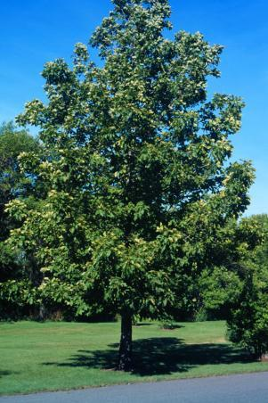 | 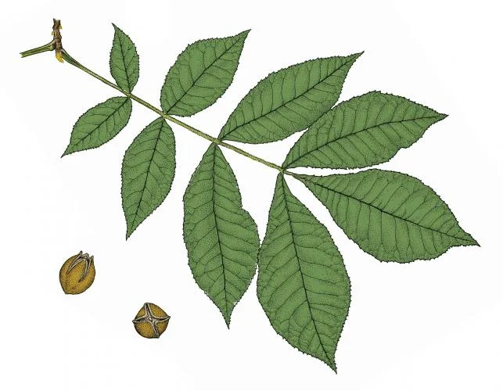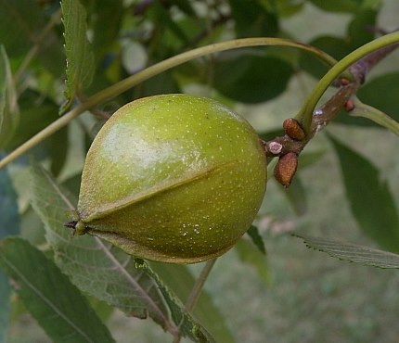 | Like other hickories, the wood from this tree can be used for smoking meats and making them more flavourful.  Due to its combination of strength, flexibility and shock-absorbing qualities, hickory wood has often been used in tool handles like hammers and axes.  While not tasty to humans, the meat from this nut is packed with oil that was extracted by Indigenous cultures long ago. | Bitternut Hickory - Awesome Tree  Carya cordiformis (bitternut hickory)
Black Walnut (Juglans nigra)  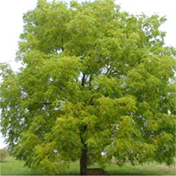 | 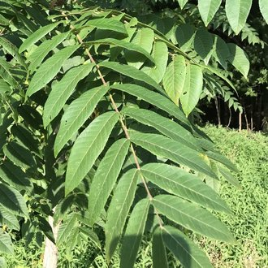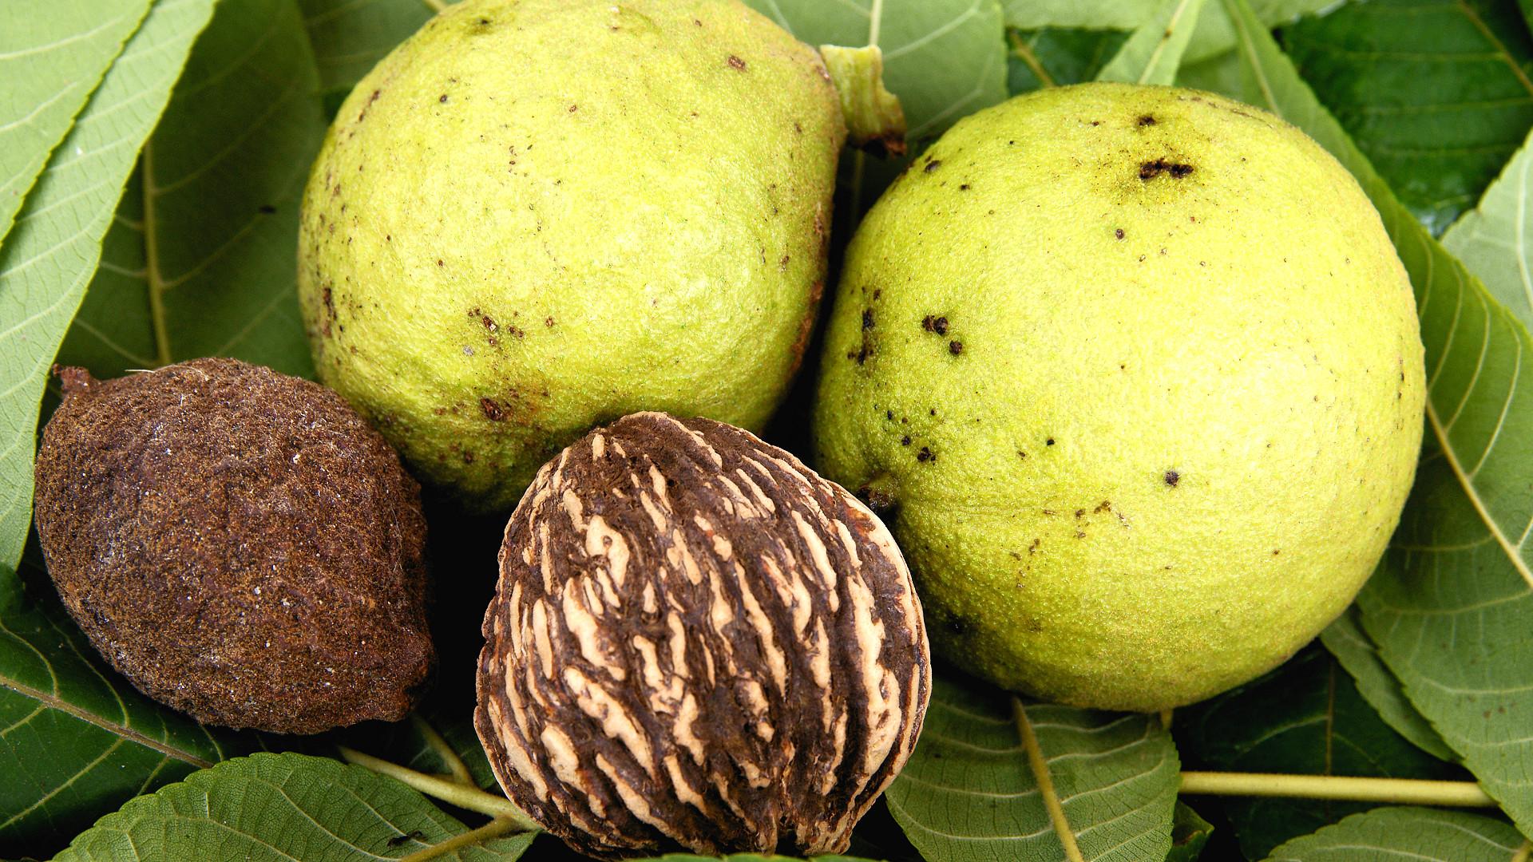 | The outer, fleshy, soft husk of the edible walnut contains chemicals (juglone, plumbagin and tannins) that can cause the fingers of people shelling them to temporarily stain black. Some settlers apparently used this stain to dye their hair and clothing items.  Some tire companies use the hard, durable, ground-up walnut shells to add traction to their winter tires! | https://youtu.be/DCwybrGFIrQ
Eastern Redbud (Cercis canadensis)  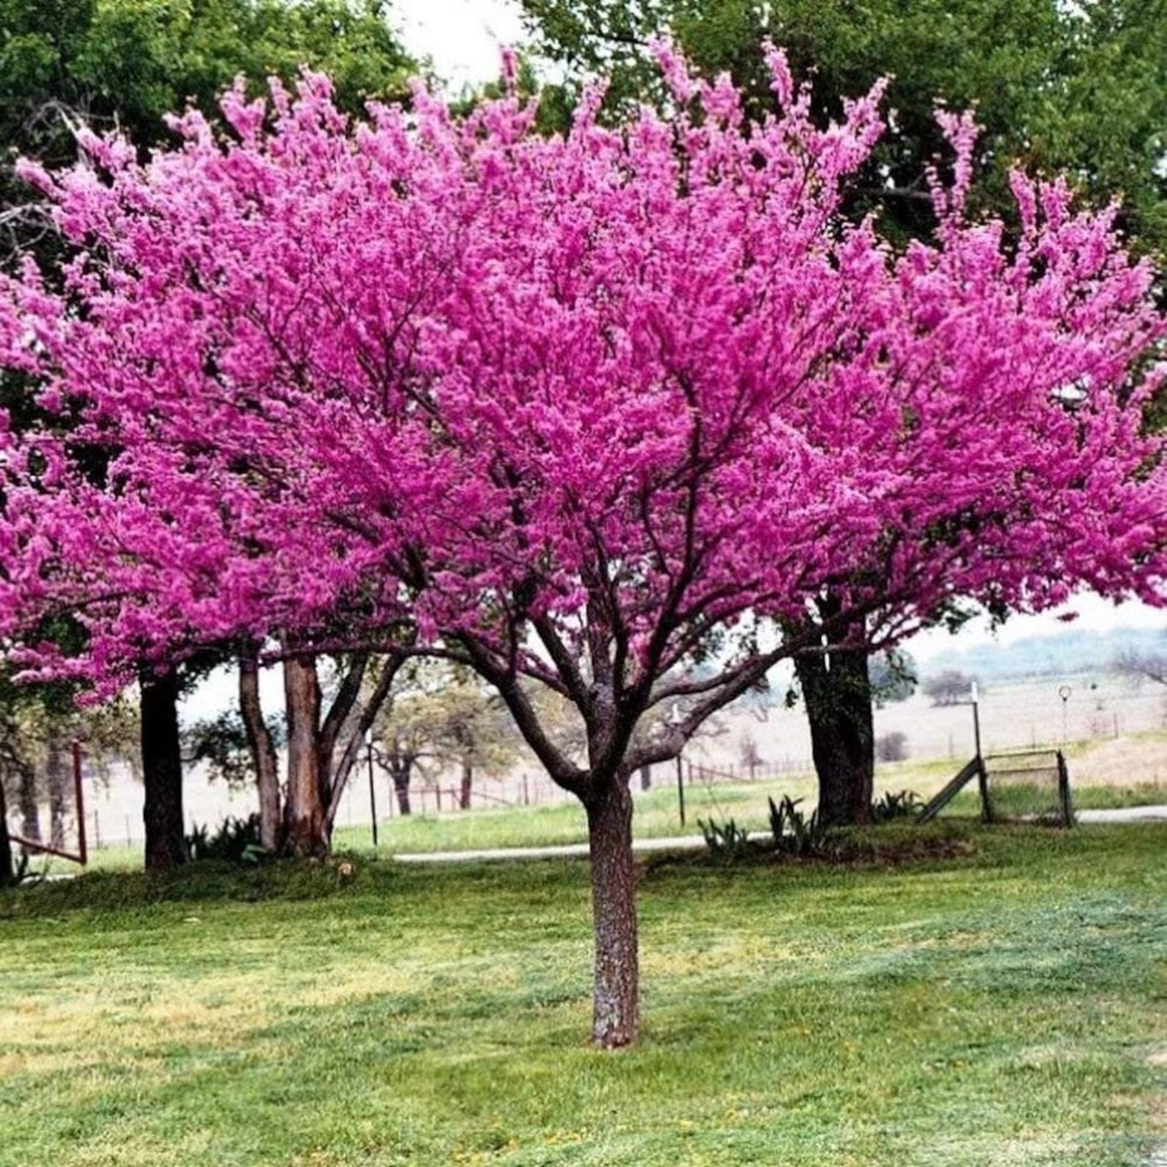  (during Spring flowering) | 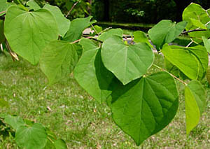  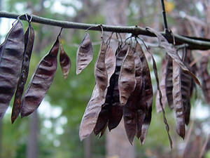 | The colourful and stunning purple/pink flowers that bloom in Spring will often attract hummingbirds.  The small seeds are located in dark brown pods (that look like pea pods) that hang from the tree in the Fall.  The tree is sometimes referred to as the spicewood tree because its green twigs can be used to season meat.  The Eastern redbud can easily be distinguished by its large heart-shaped leaves. | How to Grow Eastern Redbud Tree from Seed  How to save Eastern Redbud Seeds
Kentucky Coffee Tree (Gymnocladus dioicus)  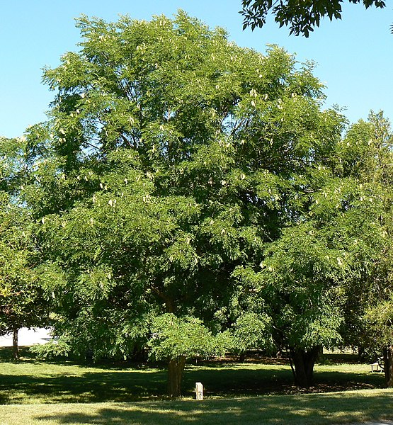 | 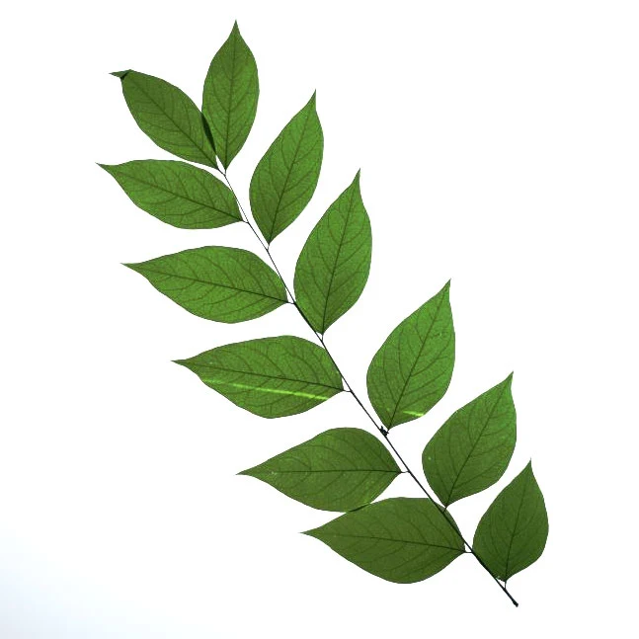  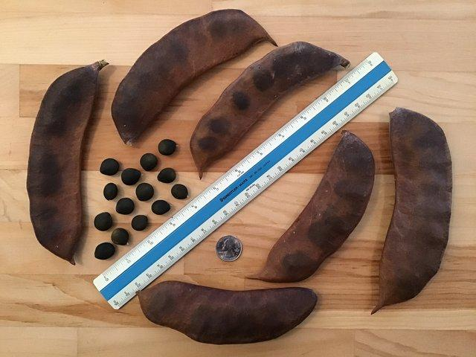 | While the name of the tree is The Kentucky Coffee Tree, it is naturally found as far north as Southern Ontario.  It is believed that the seeds of the tree were spread mostly by mastadons, large elephant-like mammals that went extinct thousands of years ago. After swallowing the seed pods, the churning within the acidic stomach would help break down the tough outer seed coat and eventually allow the seed (deposited later in a large mound of dung) to germinate and spread farther from the parent tree.  Humans can mimic the digestive system of the mastodon by “scarifying” the seed - scraping the tough outer surface with a file or sandpaper, then soaking in water for 24 hours. | How to grow Kentucky Coffee Trees from Seed  Growing a kentucky coffeetree from seed. Start to finish!!

If you want to start in the Spring instead, look around for the seeds of these trees:

Type of Tree (with scientific name and accompanying image) | Image of leaves and seed produced | Some interesting facts about the tree | Links to other helpful resources to assist with seed collection and growing
Silver maple (Acer saccharinum)  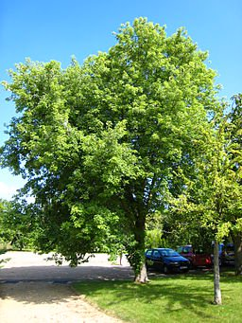 | 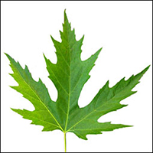  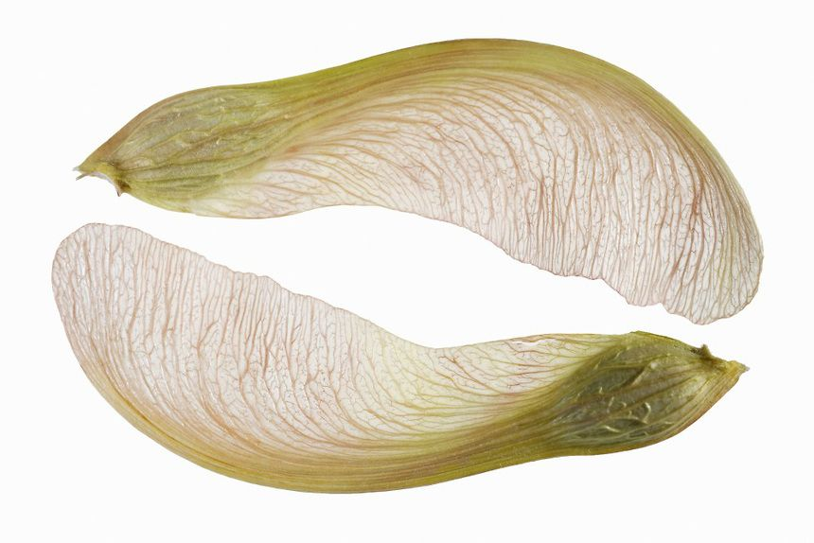 | The Silver maple gets its name from the silvery underside of its leaves.  When its branches are broken, quite an unpleasant smell is often detected.  Because this tree grows quickly, it’s often planted to provide shade or block unsightly views.  Silver maple sap was used by indigenous north americans as a healing remedy for ailments such as cramps to coughs and diarrhea to sores and measles. | How to grow Silver Maple trees from seed
Red maple  (Acer rubrum)  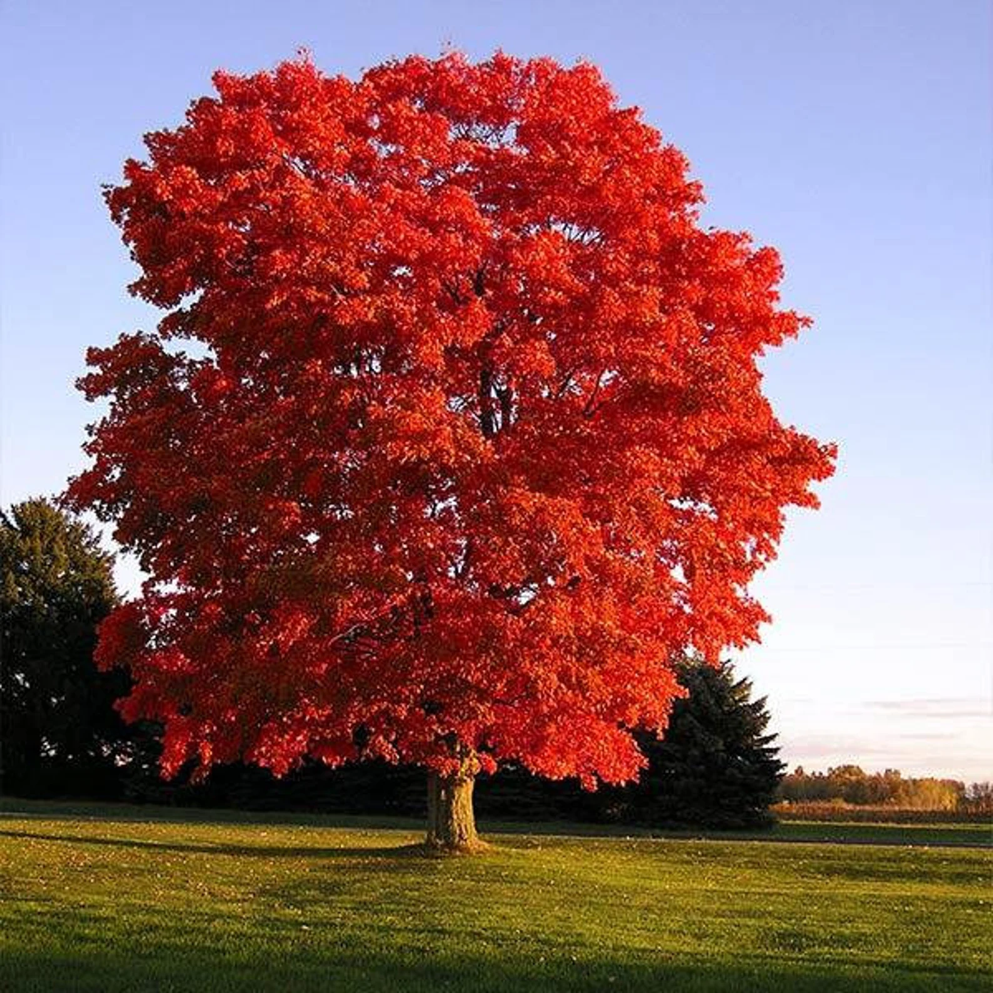  (photo taken in autumn) | 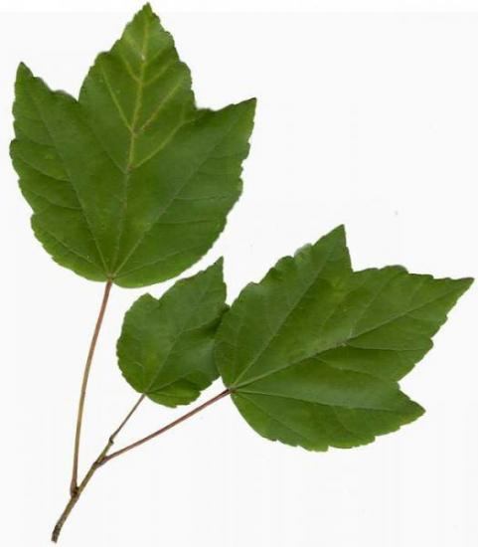  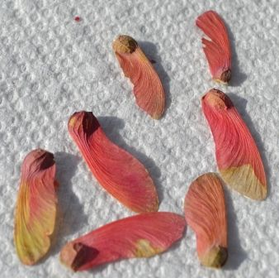 | The Red maple earned its name because of the typical brilliant, fiery red leaves it displays each autumn.  It is the most abundant native tree species in North America.  One large Red maple tree can produce over one million seeds each year! | How to grow Silver Maple trees from seed  (note: the approach for growing Silver maple from seed is the same as Red maple - just make sure to distinguish the Red maple from Silver maple first!)

